System Design

The proposed middleware, PSWare, mainly consists of two parts: first, the EDL compiler compiles the programs into bytecodes which will be disseminated into the network. Second, the VM-based middleware will execute the bytecodes and use our event detection protocol to monitor, detect and deliver the events.

1 System Architecture

The architecture of our system is shown in the diagram below:

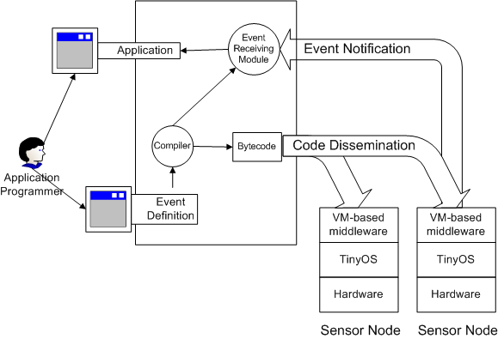
Figure 1: System architecture

The application programmer first defines the events to be subscribed in EDL. The compiler will compile the program into two parts. The fist part is the bytecodes which will later be disseminated and executed on individual sensor nodes. The second part is the event receiving module which is a Java program running on the terminal. It will interpret the data sent by the sensor nodes and notify the application programmer about the incoming events. The application programmer will also need to write a Java application which uses the interface provided by the Event Receiving Module.
The API of the Java event receiving module is defined as follows:
interface Notification {
public void notify (Event e);
}
abstract class Subscriber {
public boolean subscribe (String edl, Notification notifier);
}
To use the middleware, the application programmer needs to write a class to implement the notify method in Notification interface. Then they call the subscribe function provided by the middleware. The parameters of the subscribe function include the EDL program and the object which implements the notify method.

2 The EDL Compiler

The structure of the EDL compiler is shown in the following Figure
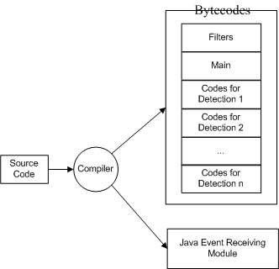
Figure 2: EDL compiler

The output of the EDL includes the bytecodes and the Java program. The bytecodes include some program images where each program image consists of some instructions. The following program images will be produced:
Filters are the instructions generated from the event filters and they are used to construct the event forwarding table. It is executed immediately after the all the program images are installed.
Main is the starting point of the program. After the filters finish execution, the main program image will start to be executed.
Detection codes are a group of program images which will start execution when event composition happens. Each ‘composite()’ has a corresponding composition image. In our current system prototype, the max number of composition codes is fixed. If there are more ‘composite()’ functions than the max number. The extra ‘composite ()’ function will have to be evaluated on the terminal by the Java Event Receiving Module.

3 The VM Runtime Environment

Our VM-based middleware is based on Mate. It provides a runtime environment to execute the program image produced by the EDL compiler. The structure of the VM runtime environment is as follows:

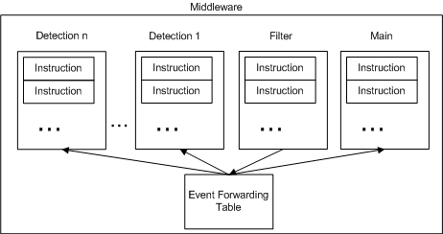
Figure 3: VM-based runtime environment

The VM has several contexts. Each context will be used to execute the corresponding program image produced by the compiler. The filter context will construct the event forwarding table used by other contexts. Upon the detection of an event, the sensor node will execute an instruction called ‘send’ with the event ID as the operand. The ‘send’ instruction will look at the event forwarding table and select the parent from the event forwarding table

